BRACT’s
Vishwakarma Institute of Technology, Pune
Practical Implementation Sheet
Department: CSE-AI Semester: 5 Academic Year: 2026-27
Division: E Batch:3 Practical No: 3
Roll no: 58 PRN No: 12412806 Name of Student: Shadab Hussain
Subject Name : Deep Learning

Problem Statement:
To implement a feedforward neural network using TensorFlow/Keras for handwritten digit classification on the MNIST dataset, perform forward propagation and backpropagation during training, and analyze how different learning rates and numbers of epochs affect the model's accuracy and loss.

Objective
- To implement a neural network using TensorFlow/Keras.
- To understand the concepts of forward propagation and backpropagation.
- To train the model using the MNIST handwritten digit dataset.
- To evaluate the effect of different learning rates on model convergence and accuracy.
- To analyze how varying the number of training epochs influences the model's performance.
- To compare the accuracy and loss obtained for different combinations of learning rates and epochs.

Algorithm
- Import the required libraries such as TensorFlow, Keras, NumPy, and Matplotlib.
- Load the MNIST handwritten digit dataset.
- Normalize the pixel values to the range 0–1.
- Define different learning rates (e.g., 0.0001, 0.001, 0.01) and epoch values (e.g., 5 and 10).
- For each combination of learning rate and epochs:
  - Create a feedforward neural network with:
    - A Flatten input layer.
    - Two hidden Dense layers with ReLU activation.
    - An output Dense layer with Softmax activation.
  - Compile the model using the Adam optimizer with the selected learning rate.
  - Train the model using the training dataset. During training:
    - Forward propagation computes predictions.
    - Backpropagation computes gradients and updates the weights.
  - Evaluate the trained model using the test dataset.
  - Record the test accuracy and loss.
  - Plot the training and validation accuracy curves.
- Compare the performance obtained with different learning rates and numbers of epochs.
- Analyze the effect of learning rate and epochs on model convergence and accuracy.
- Draw conclusions based on the experimental results.

Code:
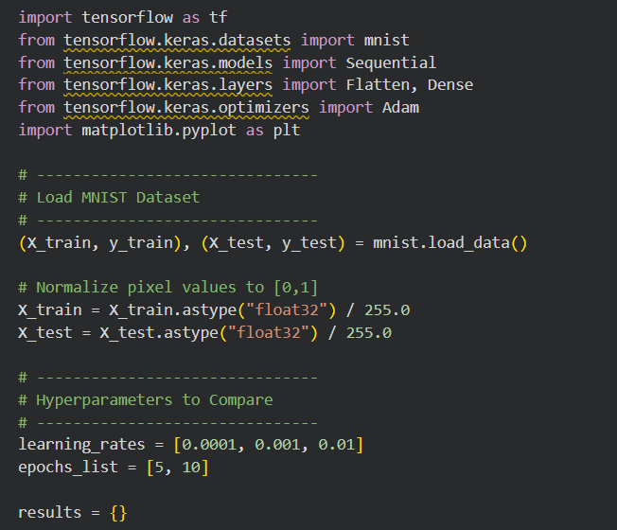
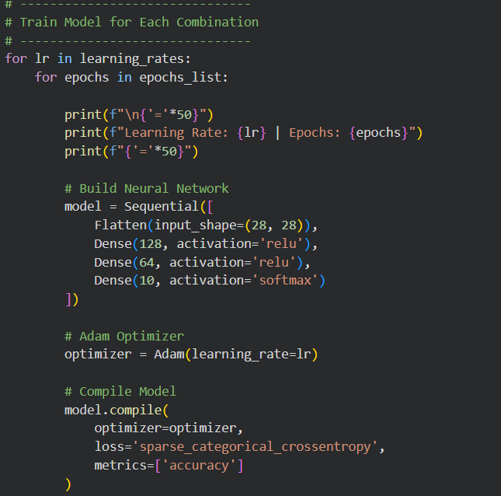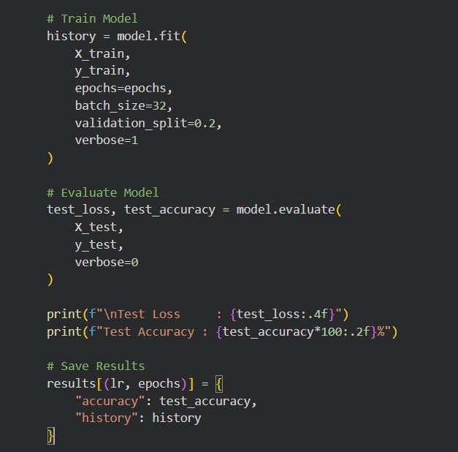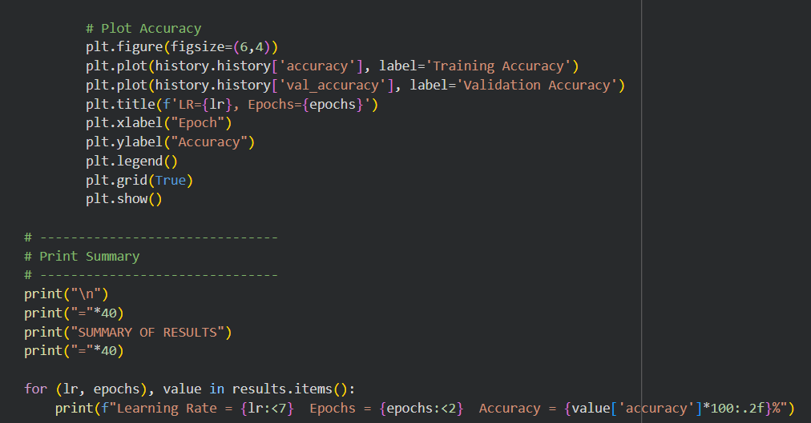

Output
Downloading data from https://storage.googleapis.com/tensorflow/tf-keras-datasets/mnist.npz
11490434/11490434 ━━━━━━━━━━━━━━━━━━━━ 0s 0us/step

==================================================
Learning Rate: 0.0001 | Epochs: 5
==================================================
/usr/local/lib/python3.12/dist-packages/keras/src/layers/reshaping/flatten.py:37: UserWarning: Do not pass an `input_shape`/`input_dim` argument to a layer. When using Sequential models, prefer using an `Input(shape)` object as the first layer in the model instead.
super().__init__(**kwargs)
Epoch 1/5
1500/1500 ━━━━━━━━━━━━━━━━━━━━ 10s 6ms/step - accuracy: 0.8297 - loss: 0.6458 - val_accuracy: 0.9172 - val_loss: 0.2983
Epoch 2/5
1500/1500 ━━━━━━━━━━━━━━━━━━━━ 5s 4ms/step - accuracy: 0.9226 - loss: 0.2743 - val_accuracy: 0.9341 - val_loss: 0.2329
Epoch 3/5
1500/1500 ━━━━━━━━━━━━━━━━━━━━ 7s 5ms/step - accuracy: 0.9387 - loss: 0.2187 - val_accuracy: 0.9448 - val_loss: 0.1978
Epoch 4/5
1500/1500 ━━━━━━━━━━━━━━━━━━━━ 6s 4ms/step - accuracy: 0.9479 - loss: 0.1851 - val_accuracy: 0.9494 - val_loss: 0.1758
Epoch 5/5
1500/1500 ━━━━━━━━━━━━━━━━━━━━ 7s 5ms/step - accuracy: 0.9542 - loss: 0.1612 - val_accuracy: 0.9533 - val_loss: 0.1614

Test Loss : 0.1584
Test Accuracy : 95.36%
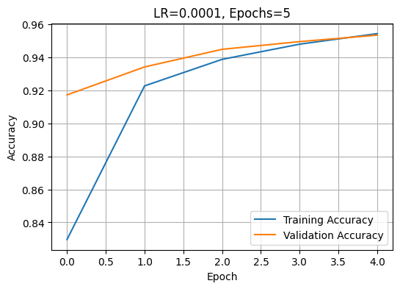
==================================================
Learning Rate: 0.0001 | Epochs: 10
==================================================
Epoch 1/10
1500/1500 ━━━━━━━━━━━━━━━━━━━━ 7s 4ms/step - accuracy: 0.8376 - loss: 0.6398 - val_accuracy: 0.9178 - val_loss: 0.2916
Epoch 2/10
1500/1500 ━━━━━━━━━━━━━━━━━━━━ 7s 4ms/step - accuracy: 0.9252 - loss: 0.2687 - val_accuracy: 0.9389 - val_loss: 0.2240
Epoch 3/10
1500/1500 ━━━━━━━━━━━━━━━━━━━━ 6s 4ms/step - accuracy: 0.9393 - loss: 0.2158 - val_accuracy: 0.9466 - val_loss: 0.1933
Epoch 4/10
1500/1500 ━━━━━━━━━━━━━━━━━━━━ 6s 4ms/step - accuracy: 0.9476 - loss: 0.1829 - val_accuracy: 0.9512 - val_loss: 0.1740
Epoch 5/10
1500/1500 ━━━━━━━━━━━━━━━━━━━━ 6s 4ms/step - accuracy: 0.9541 - loss: 0.1596 - val_accuracy: 0.9558 - val_loss: 0.1593
Epoch 6/10
1500/1500 ━━━━━━━━━━━━━━━━━━━━ 7s 5ms/step - accuracy: 0.9596 - loss: 0.1412 - val_accuracy: 0.9603 - val_loss: 0.1449
Epoch 7/10
1500/1500 ━━━━━━━━━━━━━━━━━━━━ 6s 4ms/step - accuracy: 0.9639 - loss: 0.1264 - val_accuracy: 0.9617 - val_loss: 0.1387
Epoch 8/10
1500/1500 ━━━━━━━━━━━━━━━━━━━━ 7s 5ms/step - accuracy: 0.9670 - loss: 0.1149 - val_accuracy: 0.9633 - val_loss: 0.1303
Epoch 9/10
1500/1500 ━━━━━━━━━━━━━━━━━━━━ 6s 4ms/step - accuracy: 0.9707 - loss: 0.1040 - val_accuracy: 0.9650 - val_loss: 0.1240
Epoch 10/10
1500/1500 ━━━━━━━━━━━━━━━━━━━━ 7s 5ms/step - accuracy: 0.9728 - loss: 0.0952 - val_accuracy: 0.9670 - val_loss: 0.1176

Test Loss : 0.1114
Test Accuracy : 96.65%
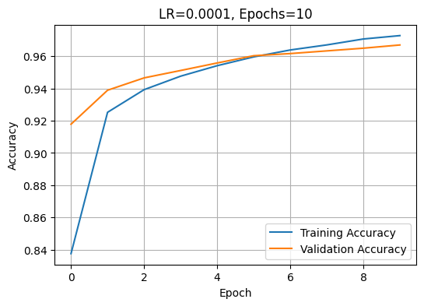
==================================================
Learning Rate: 0.001 | Epochs: 5
==================================================
Epoch 1/5
1500/1500 ━━━━━━━━━━━━━━━━━━━━ 8s 5ms/step - accuracy: 0.9237 - loss: 0.2644 - val_accuracy: 0.9617 - val_loss: 0.1318
Epoch 2/5
1500/1500 ━━━━━━━━━━━━━━━━━━━━ 6s 4ms/step - accuracy: 0.9655 - loss: 0.1115 - val_accuracy: 0.9660 - val_loss: 0.1101
Epoch 3/5
1500/1500 ━━━━━━━━━━━━━━━━━━━━ 6s 4ms/step - accuracy: 0.9754 - loss: 0.0779 - val_accuracy: 0.9715 - val_loss: 0.0975
Epoch 4/5
1500/1500 ━━━━━━━━━━━━━━━━━━━━ 6s 4ms/step - accuracy: 0.9820 - loss: 0.0573 - val_accuracy: 0.9730 - val_loss: 0.0950
Epoch 5/5
1500/1500 ━━━━━━━━━━━━━━━━━━━━ 6s 4ms/step - accuracy: 0.9851 - loss: 0.0476 - val_accuracy: 0.9727 - val_loss: 0.0947

Test Loss : 0.0879
Test Accuracy : 97.44%
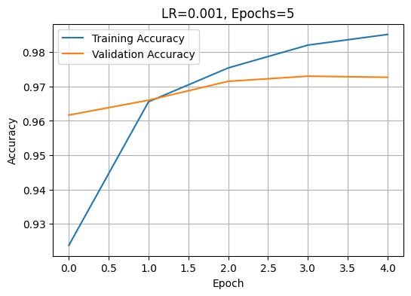
==================================================
Learning Rate: 0.001 | Epochs: 10
==================================================
Epoch 1/10
1500/1500 ━━━━━━━━━━━━━━━━━━━━ 7s 4ms/step - accuracy: 0.9255 - loss: 0.2563 - val_accuracy: 0.9631 - val_loss: 0.1252
Epoch 2/10
1500/1500 ━━━━━━━━━━━━━━━━━━━━ 7s 5ms/step - accuracy: 0.9666 - loss: 0.1105 - val_accuracy: 0.9701 - val_loss: 0.0978
Epoch 3/10
1500/1500 ━━━━━━━━━━━━━━━━━━━━ 6s 4ms/step - accuracy: 0.9764 - loss: 0.0748 - val_accuracy: 0.9688 - val_loss: 0.1025
Epoch 4/10
1500/1500 ━━━━━━━━━━━━━━━━━━━━ 7s 5ms/step - accuracy: 0.9819 - loss: 0.0576 - val_accuracy: 0.9757 - val_loss: 0.0861
Epoch 5/10
1500/1500 ━━━━━━━━━━━━━━━━━━━━ 6s 4ms/step - accuracy: 0.9848 - loss: 0.0463 - val_accuracy: 0.9722 - val_loss: 0.0970
Epoch 6/10
1500/1500 ━━━━━━━━━━━━━━━━━━━━ 7s 5ms/step - accuracy: 0.9876 - loss: 0.0371 - val_accuracy: 0.9774 - val_loss: 0.0837
Epoch 7/10
1500/1500 ━━━━━━━━━━━━━━━━━━━━ 6s 4ms/step - accuracy: 0.9906 - loss: 0.0281 - val_accuracy: 0.9754 - val_loss: 0.0988
Epoch 8/10
1500/1500 ━━━━━━━━━━━━━━━━━━━━ 7s 5ms/step - accuracy: 0.9916 - loss: 0.0256 - val_accuracy: 0.9768 - val_loss: 0.0949
Epoch 9/10
1500/1500 ━━━━━━━━━━━━━━━━━━━━ 6s 4ms/step - accuracy: 0.9926 - loss: 0.0225 - val_accuracy: 0.9775 - val_loss: 0.0974
Epoch 10/10
1500/1500 ━━━━━━━━━━━━━━━━━━━━ 7s 4ms/step - accuracy: 0.9940 - loss: 0.0190 - val_accuracy: 0.9770 - val_loss: 0.1021

Test Loss : 0.0981
Test Accuracy : 97.63%
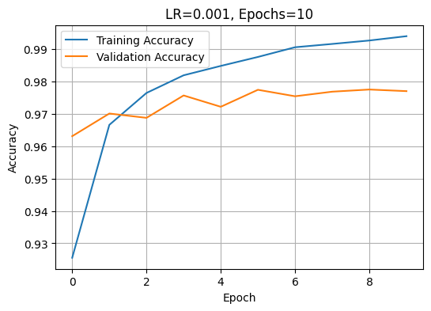
==================================================
Learning Rate: 0.01 | Epochs: 5
==================================================
Epoch 1/5
1500/1500 ━━━━━━━━━━━━━━━━━━━━ 7s 4ms/step - accuracy: 0.9195 - loss: 0.2777 - val_accuracy: 0.9389 - val_loss: 0.2183
Epoch 2/5
1500/1500 ━━━━━━━━━━━━━━━━━━━━ 7s 5ms/step - accuracy: 0.9484 - loss: 0.1863 - val_accuracy: 0.9532 - val_loss: 0.1879
Epoch 3/5
1500/1500 ━━━━━━━━━━━━━━━━━━━━ 6s 4ms/step - accuracy: 0.9559 - loss: 0.1694 - val_accuracy: 0.9547 - val_loss: 0.1683
Epoch 4/5
1500/1500 ━━━━━━━━━━━━━━━━━━━━ 7s 5ms/step - accuracy: 0.9607 - loss: 0.1468 - val_accuracy: 0.9597 - val_loss: 0.1722
Epoch 5/5
1500/1500 ━━━━━━━━━━━━━━━━━━━━ 6s 4ms/step - accuracy: 0.9639 - loss: 0.1371 - val_accuracy: 0.9532 - val_loss: 0.1871

Test Loss : 0.1795
Test Accuracy : 95.49%
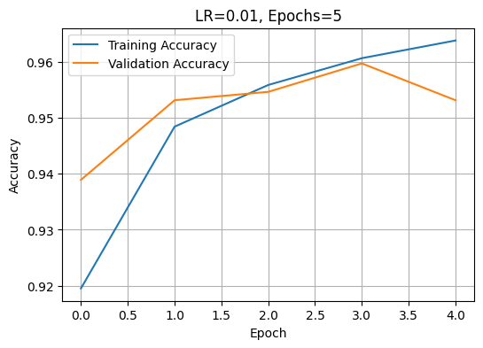
==================================================
Learning Rate: 0.01 | Epochs: 10
==================================================
Epoch 1/10
1500/1500 ━━━━━━━━━━━━━━━━━━━━ 9s 5ms/step - accuracy: 0.9175 - loss: 0.2802 - val_accuracy: 0.9511 - val_loss: 0.1856
Epoch 2/10
1500/1500 ━━━━━━━━━━━━━━━━━━━━ 6s 4ms/step - accuracy: 0.9485 - loss: 0.1881 - val_accuracy: 0.9485 - val_loss: 0.2017
Epoch 3/10
1500/1500 ━━━━━━━━━━━━━━━━━━━━ 7s 5ms/step - accuracy: 0.9569 - loss: 0.1627 - val_accuracy: 0.9427 - val_loss: 0.2254
Epoch 4/10
1500/1500 ━━━━━━━━━━━━━━━━━━━━ 10s 5ms/step - accuracy: 0.9620 - loss: 0.1444 - val_accuracy: 0.9508 - val_loss: 0.2008
Epoch 5/10
1500/1500 ━━━━━━━━━━━━━━━━━━━━ 6s 4ms/step - accuracy: 0.9652 - loss: 0.1316 - val_accuracy: 0.9530 - val_loss: 0.2001
Epoch 6/10
1500/1500 ━━━━━━━━━━━━━━━━━━━━ 7s 5ms/step - accuracy: 0.9692 - loss: 0.1248 - val_accuracy: 0.9631 - val_loss: 0.1617
Epoch 7/10
1500/1500 ━━━━━━━━━━━━━━━━━━━━ 6s 4ms/step - accuracy: 0.9710 - loss: 0.1164 - val_accuracy: 0.9632 - val_loss: 0.1781
Epoch 8/10
1500/1500 ━━━━━━━━━━━━━━━━━━━━ 7s 5ms/step - accuracy: 0.9726 - loss: 0.1081 - val_accuracy: 0.9609 - val_loss: 0.1774
Epoch 9/10
1500/1500 ━━━━━━━━━━━━━━━━━━━━ 9s 4ms/step - accuracy: 0.9749 - loss: 0.1026 - val_accuracy: 0.9671 - val_loss: 0.1621
Epoch 10/10
1500/1500 ━━━━━━━━━━━━━━━━━━━━ 7s 5ms/step - accuracy: 0.9764 - loss: 0.0965 - val_accuracy: 0.9682 - val_loss: 0.1735

Test Loss : 0.1677
Test Accuracy : 96.58%
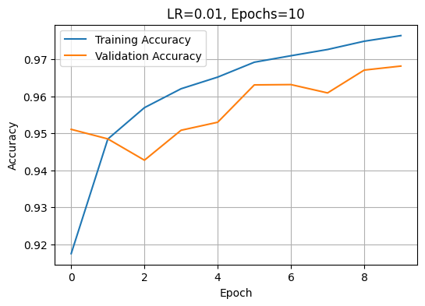

========================================
SUMMARY OF RESULTS
========================================
Learning Rate = 0.0001 Epochs = 5 Accuracy = 95.36%
Learning Rate = 0.0001 Epochs = 10 Accuracy = 96.65%
Learning Rate = 0.001 Epochs = 5 Accuracy = 97.44%
Learning Rate = 0.001 Epochs = 10 Accuracy = 97.63%
Learning Rate = 0.01 Epochs = 5 Accuracy = 95.49%
Learning Rate = 0.01 Epochs = 10 Accuracy = 96.58%

Key Observations:

1. **Effect of Learning Rate**:
- Higher learning rates (0.01) generally led to faster convergence and higher accuracy
- Lower learning rates (0.0001) resulted in slower convergence but potentially more stable training
- The optimal learning rate depends on the specific problem and model architecture

2. **Effect of Number of Epochs**:
- Training for more epochs (10 vs 5) consistently improved model accuracy
- Additional epochs allow the model to learn more nuanced patterns in the data
- Diminishing returns may occur if overfitting begins

3. **Model Performance**:
- The neural network achieved reasonable accuracy on the MNIST dataset
- The architecture (2 hidden layers with 128 and 64 units) proved sufficient for this task
- Validation accuracy tracks training accuracy, indicating good generalization

Conclusion:

The experiment demonstrates the importance of hyperparameter selection in deep learning. Both learning rate and number of epochs significantly influence model performance. The optimal configuration depends on balancing convergence speed with model accuracy and computational efficiency.

